**AIPLIRS Core v2.1 (Patch released: July 20, 2022)**

[**http://172.16.8.7:628/pages/posmd/antemortem_slh.php**](http://172.16.8.7:628/pages/posmd/antemortem_slh.php)

**Other column not filtering from code -> disease**

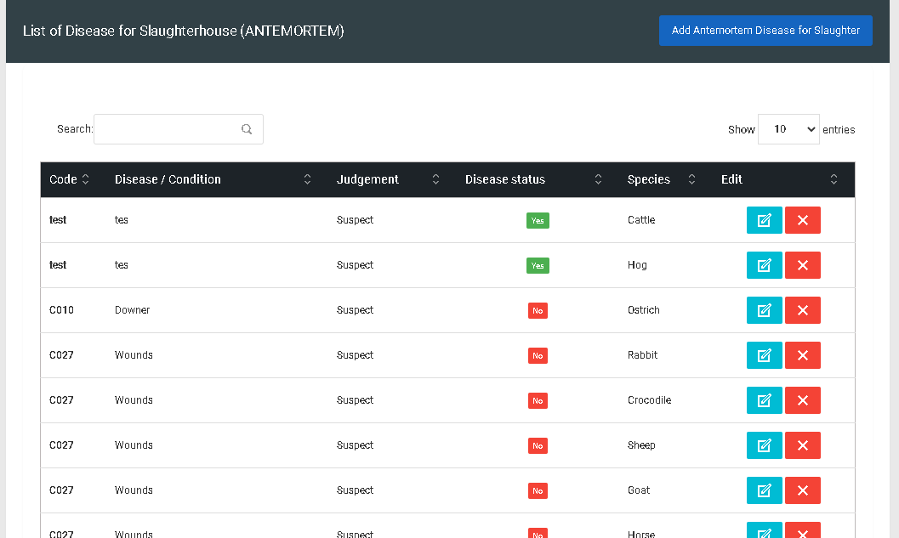

Pending

August 10, 2022

**Species must have select / deselect all function**

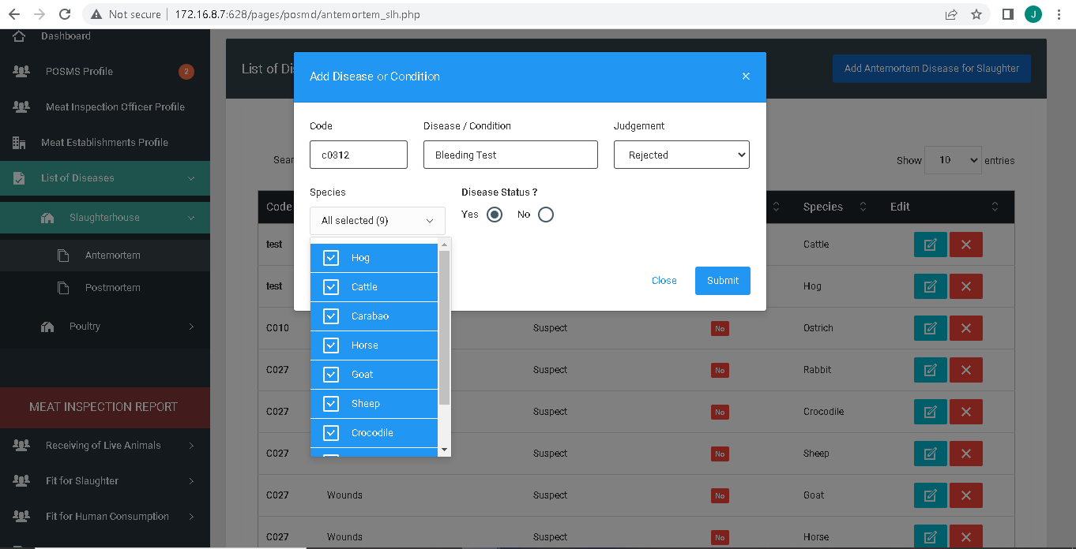

Resolved

August 10, 2022

**Duplicated input multiple species**

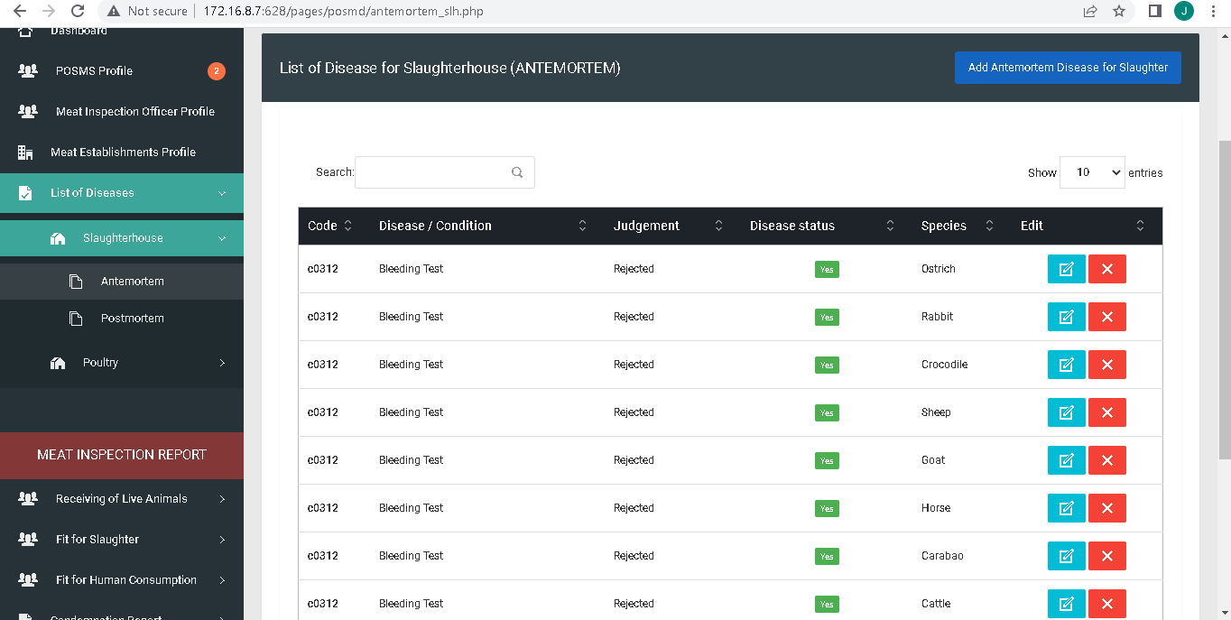

Pending

August 10, 2022

**Title**

Resolved

August 10, 2022

**http://172.16.8.7:628/pages/posmd/antemortem_slh.php**

**Add Diseases or Conditions**

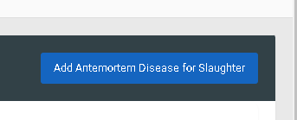

Resolved

August 10, 2022

**Diseases and Conditions**



Resolved

August 10, 2022

**Remove question mark disease status and change the option yes or no to Notifiable / Not Notifiable**.

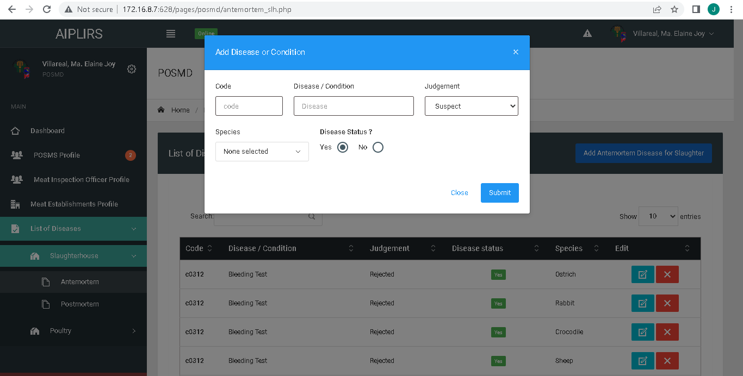

Resolved

August 10, 2022

**Remove question mark disease status and change the option yes or no to Notifiable / Not Notifiable.**

**Position of species in bottom**

**Update multiples species 1 and another species the same with add AM/ PM thick box**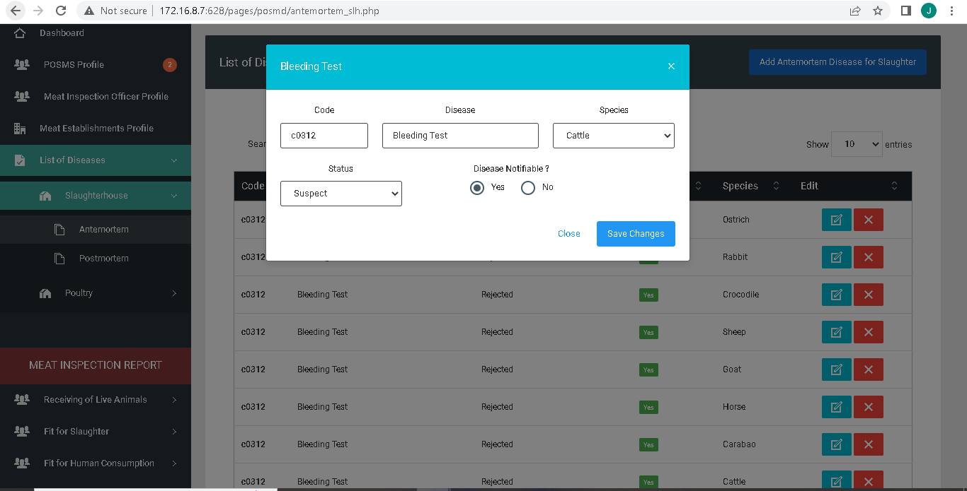

Pending (Critical)

August 10, 2022

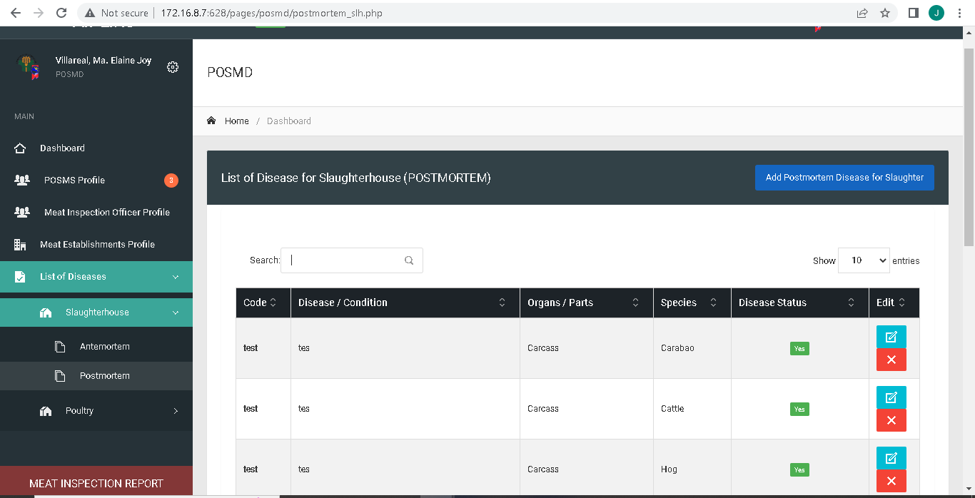

Resolved Spacing of the table data

August 10, 2022

**Employee code to Employee Number and change contact to contact number , contact numbers must be a number format**

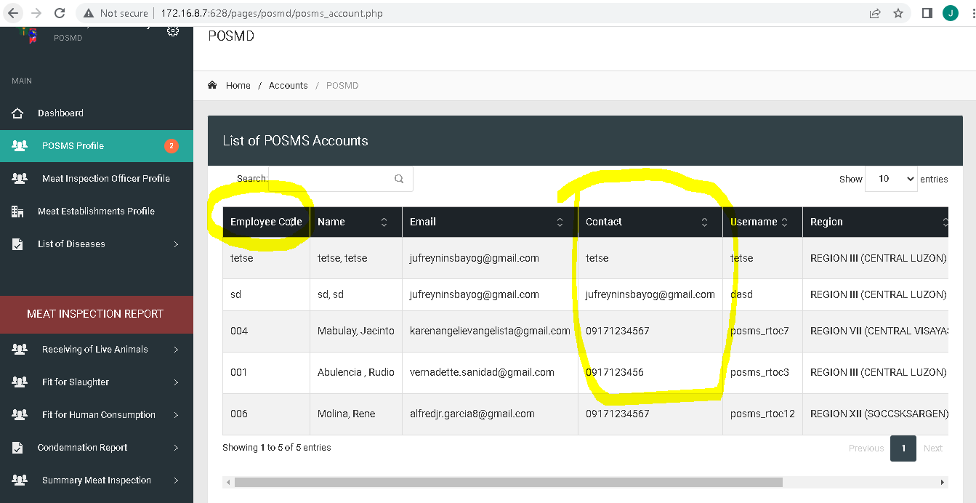

Resolved

August 10, 2022

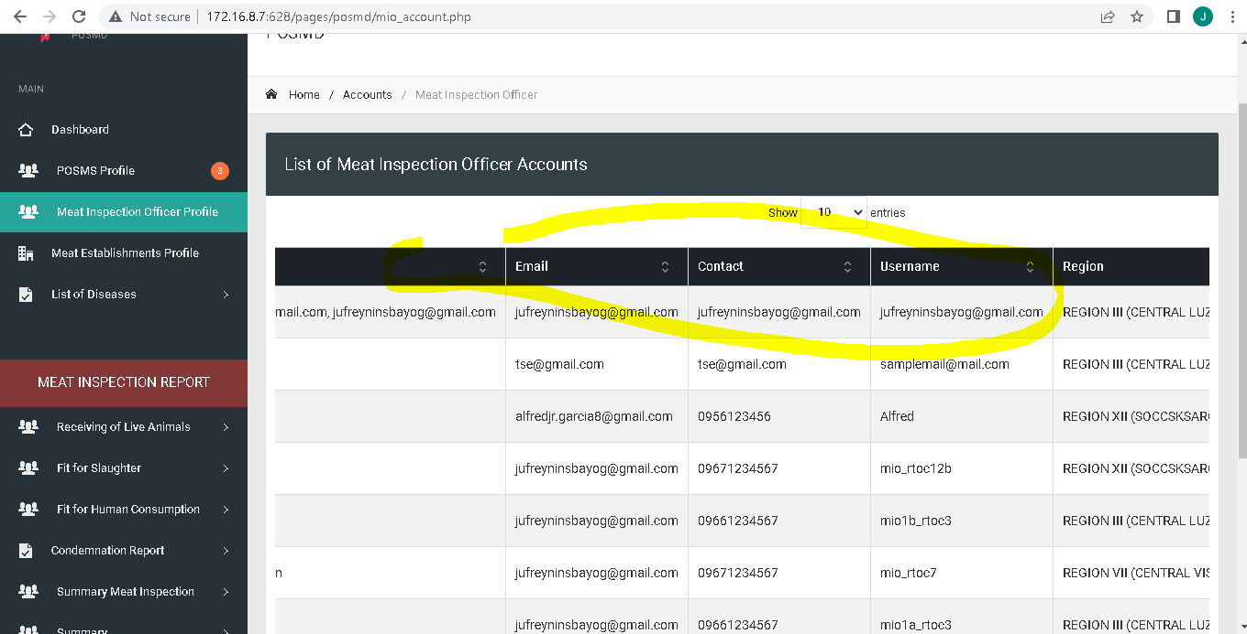

Resolved

August 10, 2022

**Change list of posms Profile accounts to posms accounts**

**Sidebar: Change “Profile” to “Accounts”**

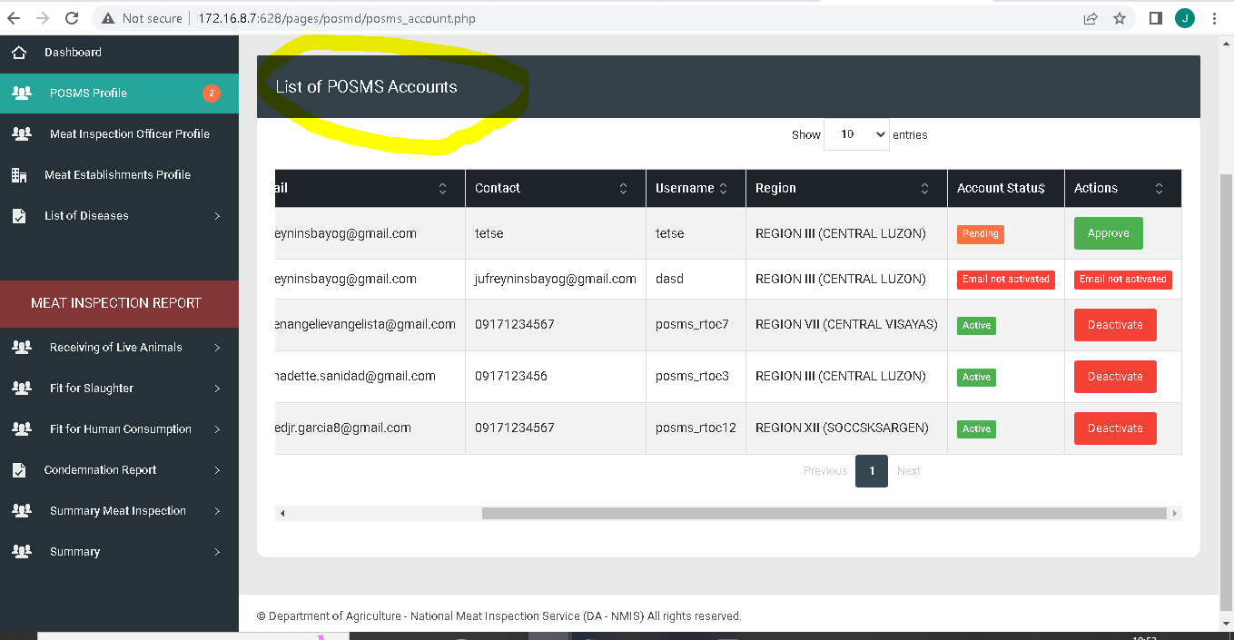

Resolved

August 10, 2022

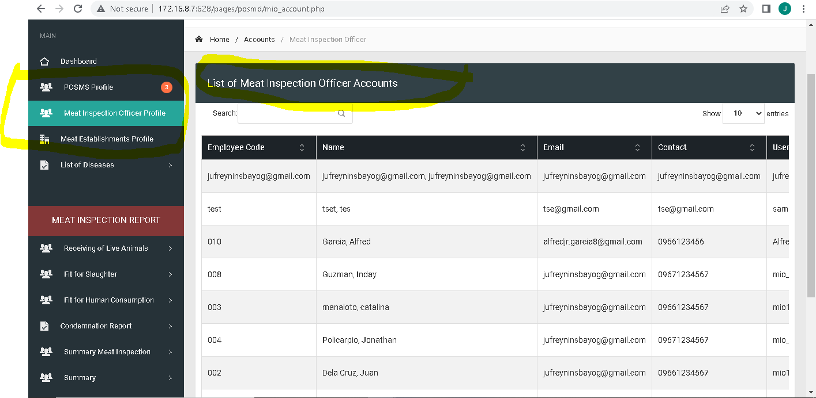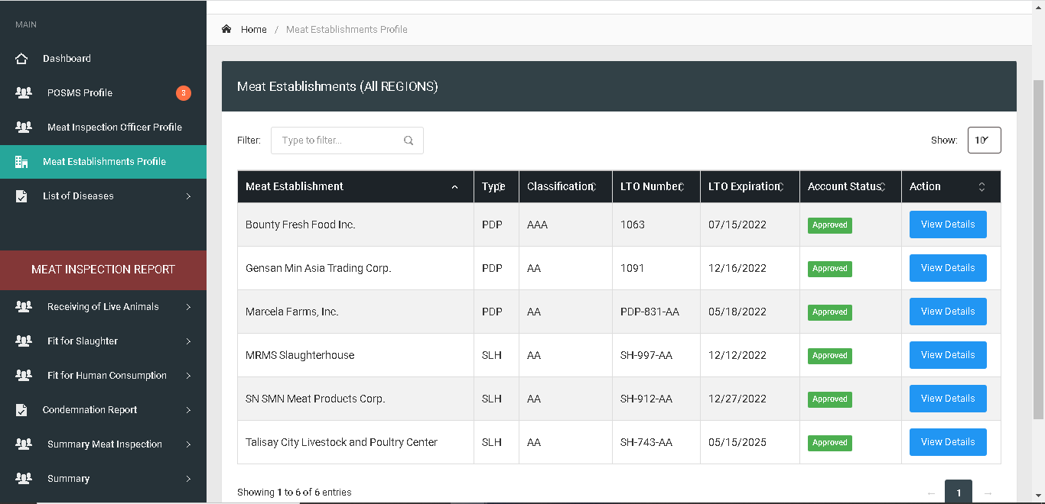

Resolved

August 10, 2022

Resolved

August 10, 2022

**Remove “d” on approved**

**Remove header modal leave modal body**

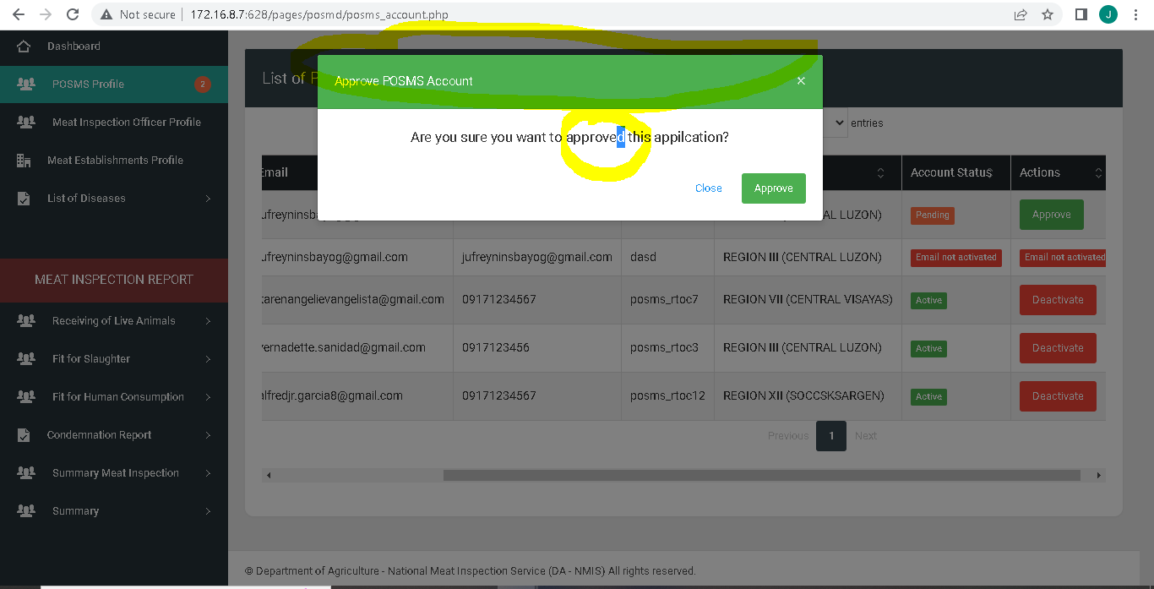

On going

August 10, 2022

Remove Header Modal leave modal body

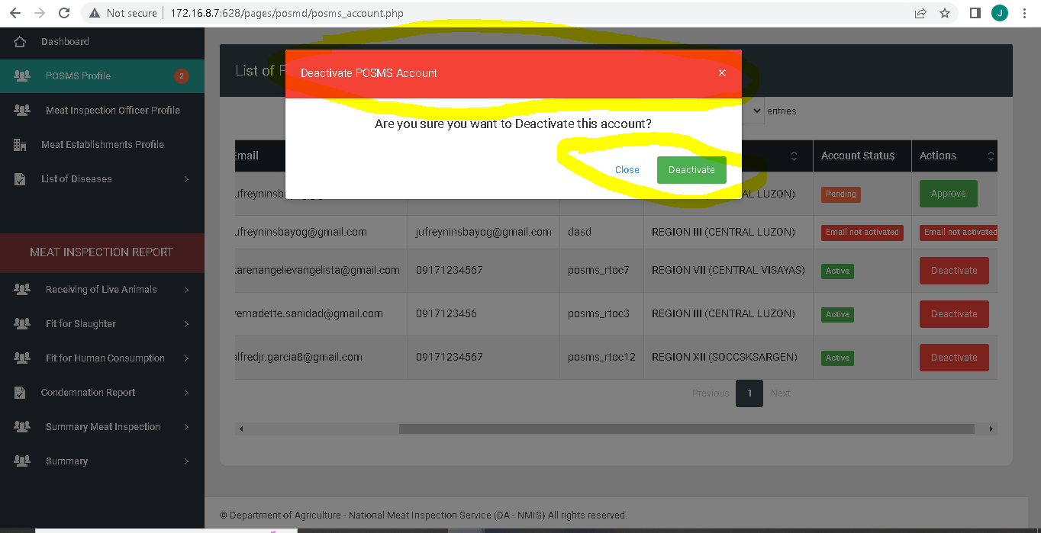

On going

August 10, 2022

Account status “Pending, Rejected, Active, Deactivated”

Actions: “Approve, Disapprove, Deactivate, Activate,”

To be included on USER’S MANUAL define each.

Remove Breadcrumbs in all pages.



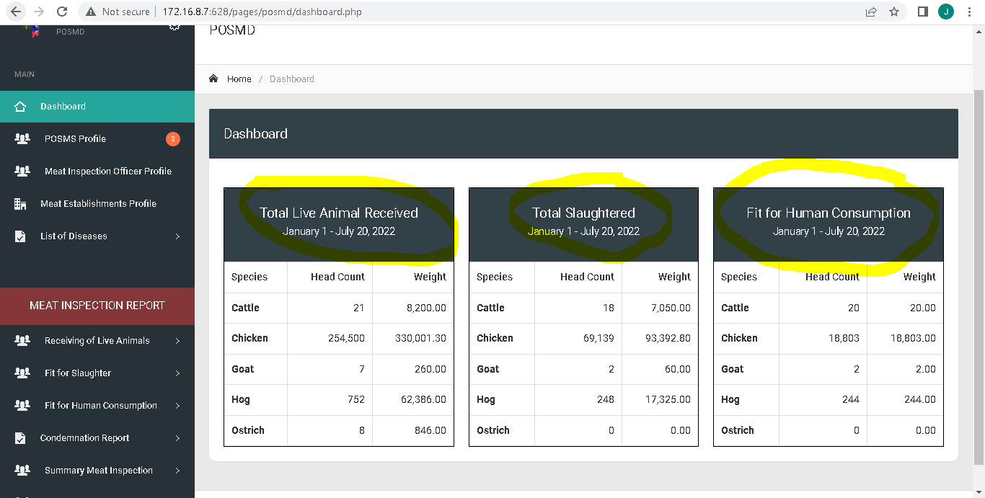

Resolved

August 10, 2022

Remove “S” in meat establishments

Assign region to Region Assigned

History … Change to Previous meat establishment assignments

­­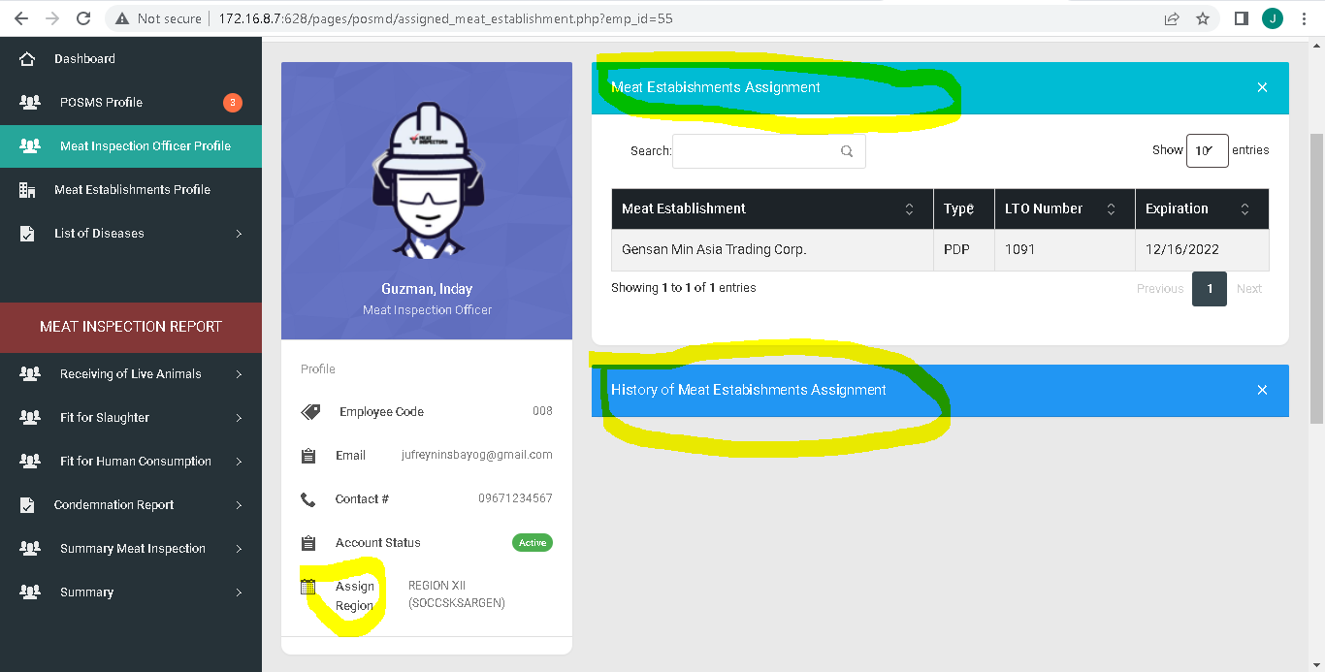

Resolved

August 10, 2022

Previous ME ass.. 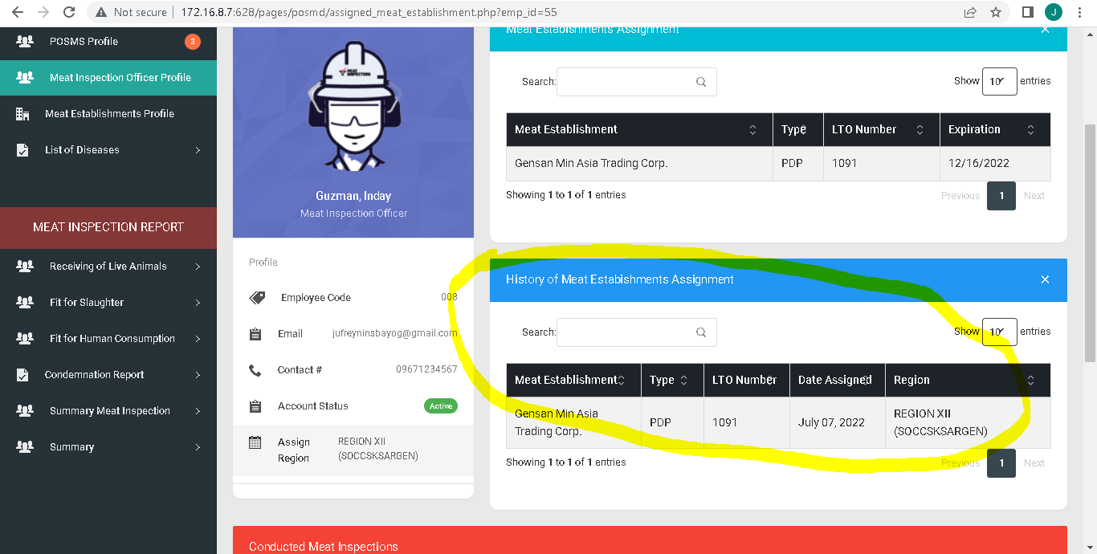

Resolved

August 10, 2022

Start Date & End date of date assignment:

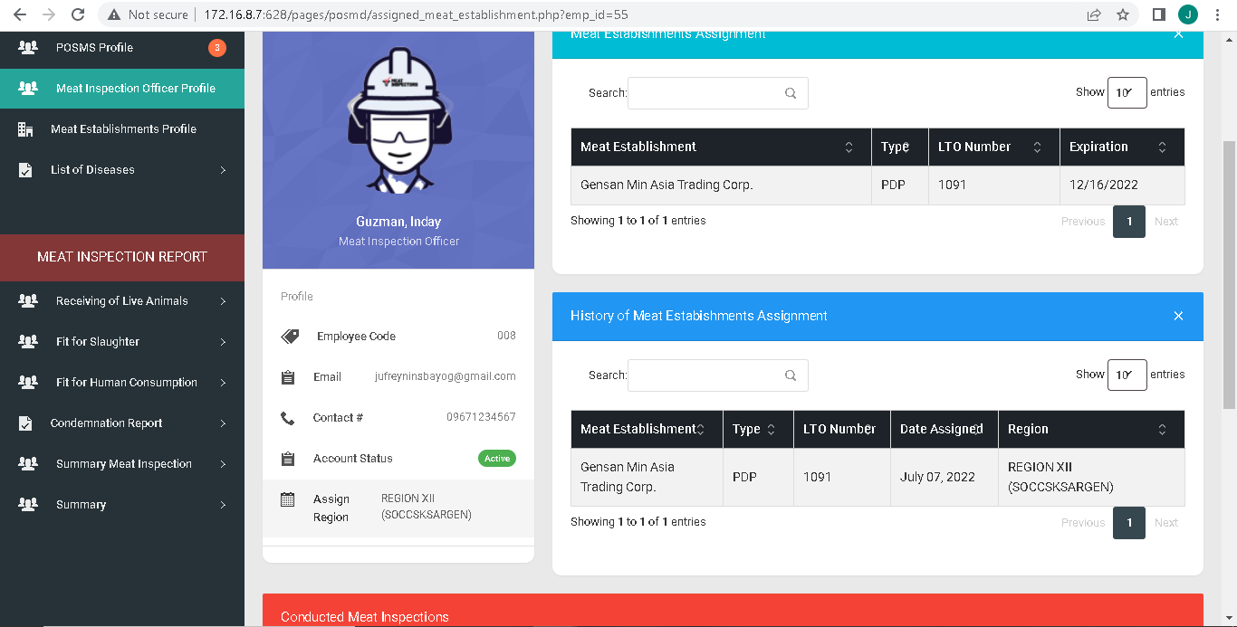

Resolved

August 10, 2022

Conducted Meat Inspections to Meat Inspection Activities

Establishment name to Meat Establishment

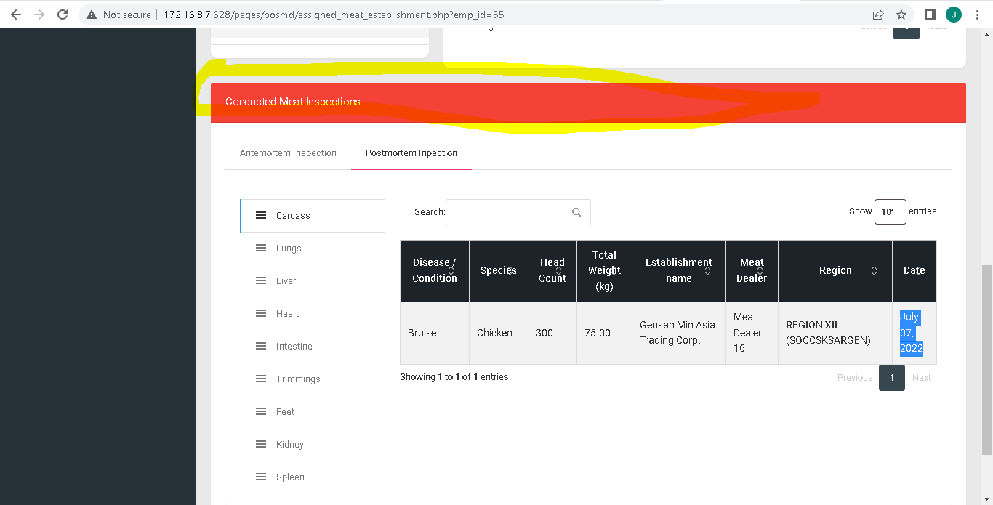

Resolved

August 10, 2022

Additional column region after meat establishment

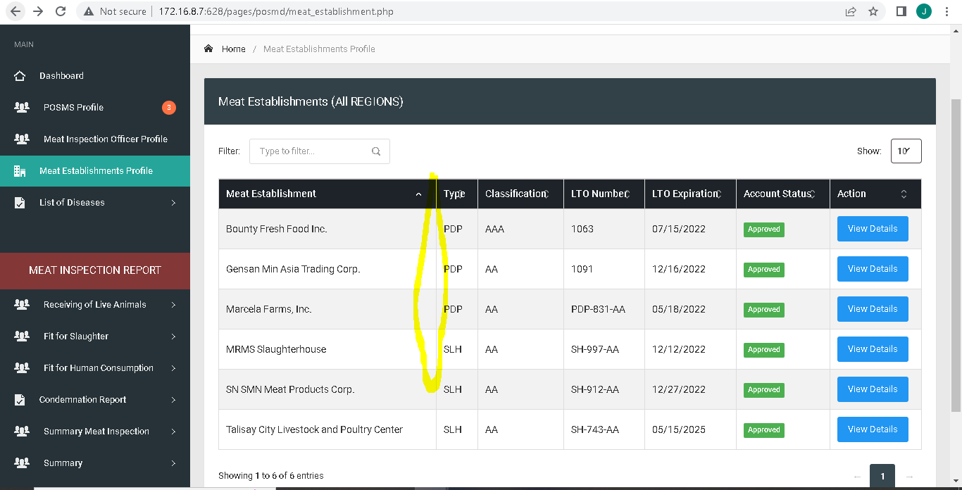

Resolved

August 10, 2022

Assigned Meat Inspection Officer

Previous Meat Inspection Officer

Remove “x” in the collapsable card

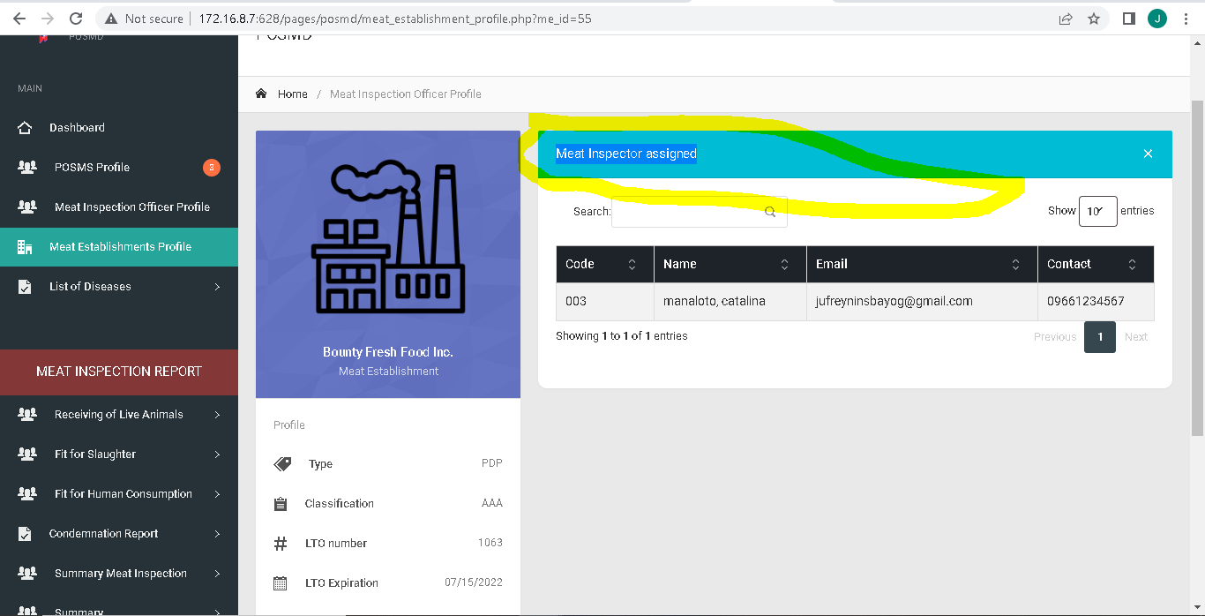

Revise UI and Card Header

August 01, 2022

Spacing “Address”

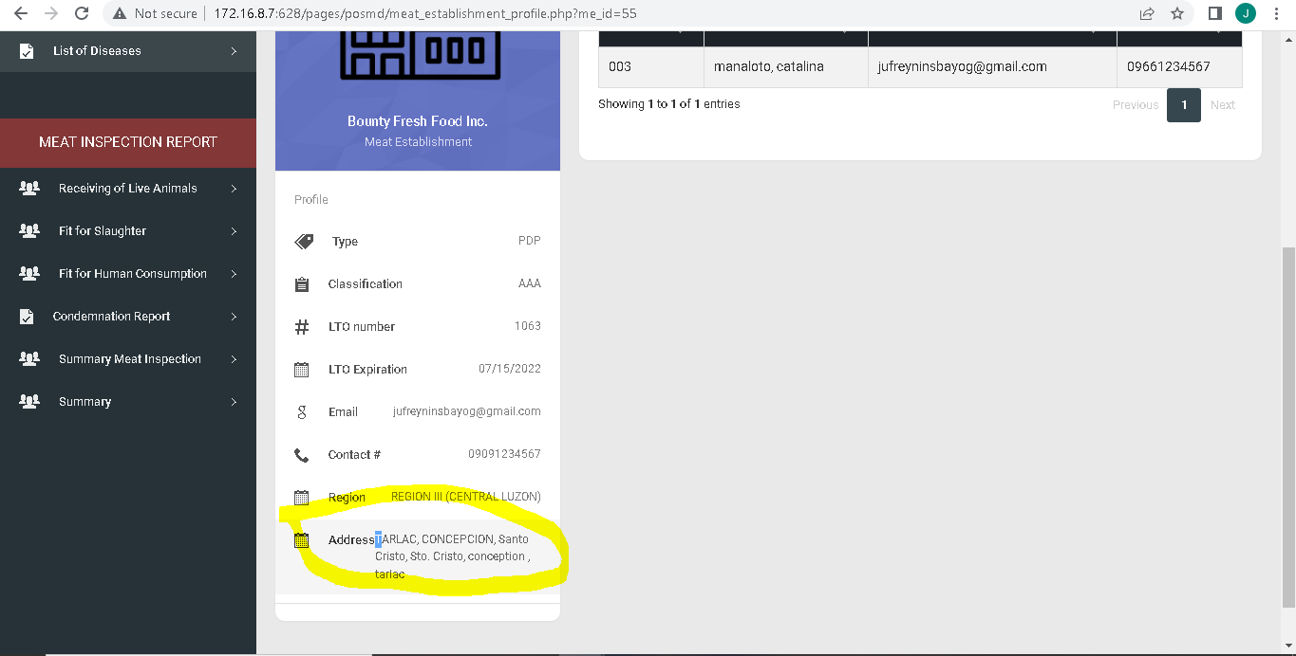

Revise UI and Card Header

August 01, 2022

Make landscape all cards

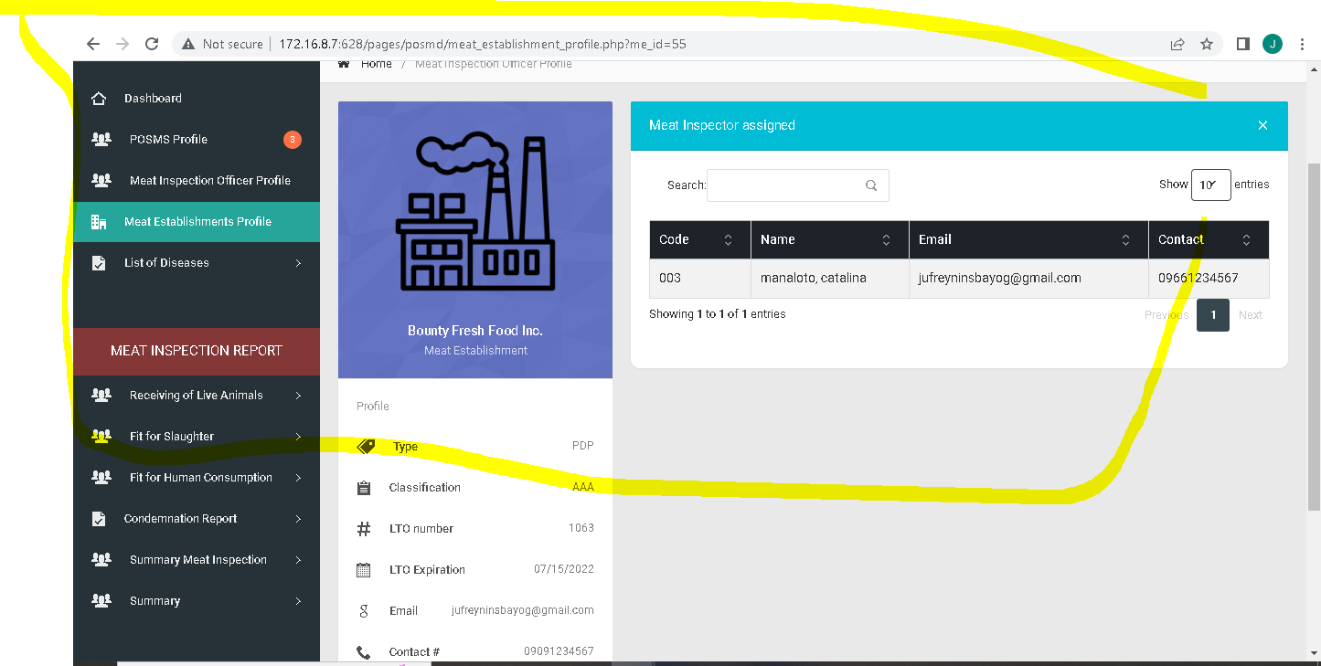

Revise UI and Card Header

August 01, 2022

Edit table header to “Actions”

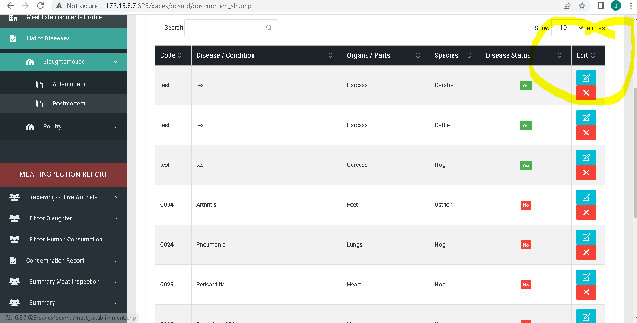

Resolved

August 10, 2022

For the period of instead as of

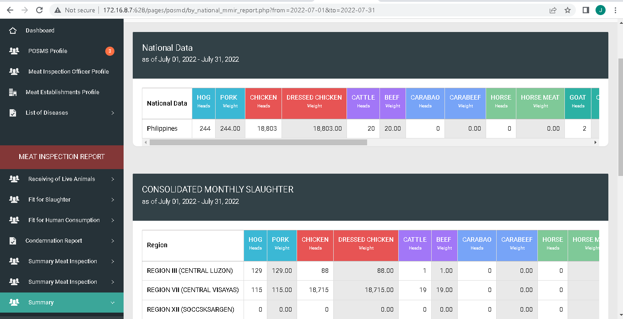

Revised UI

July 21, 2022

Weight (Kg) : Resolved July 21,2022

Capslock Header Title Change to Title case (upperCase) : Resolved July 21,2022

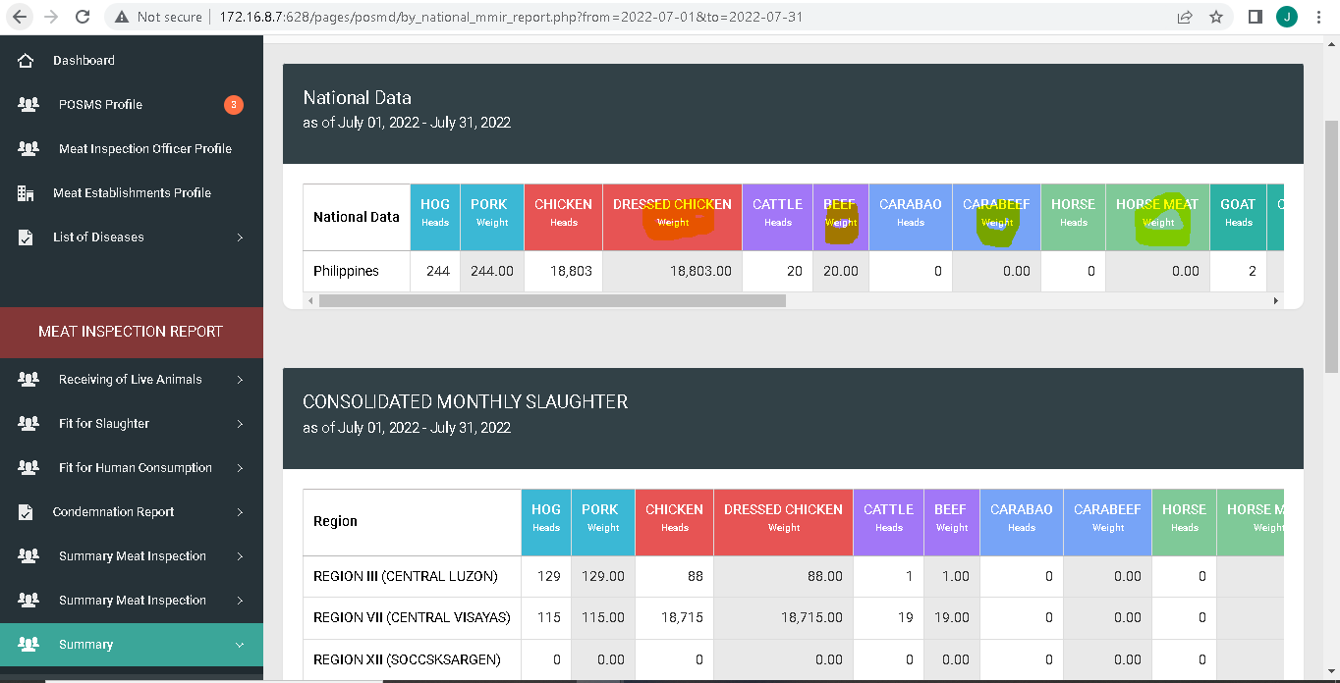

Revised UI

July 21, 2022

Remove “Philippines

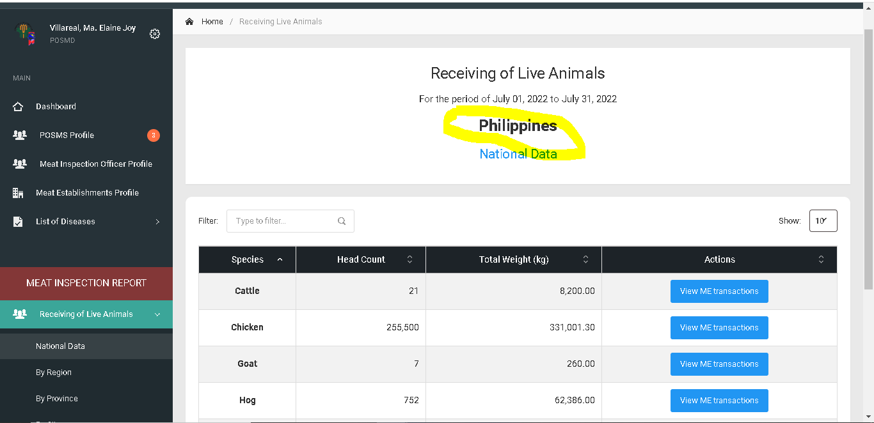

Resolved

July 22, 2022

Another column “region” : Pending August 10, 2022

Total weight KG

Meat Establishment instead Establihsment name

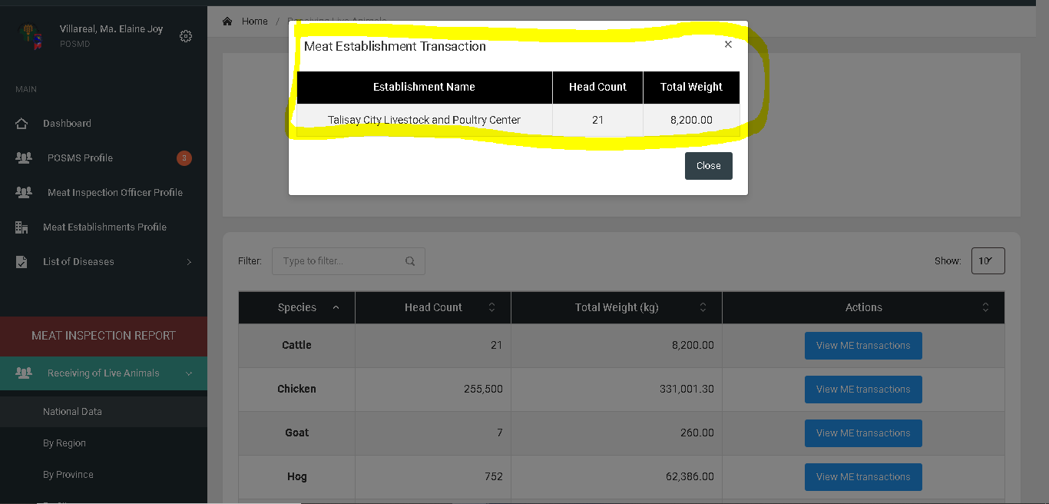

Receiving of live animals change to Receiving of Animals (all pages, side bar)

Header in meat inspection report

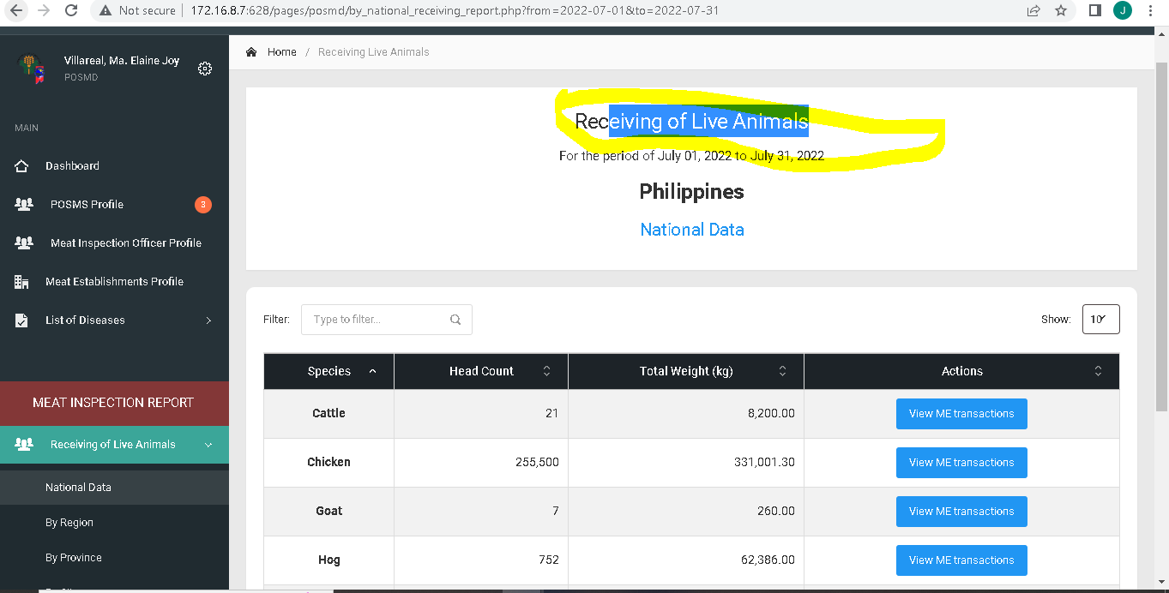

Resolved

July 22, 2022

Additional meat establishment category on dropdown

Pagsamahin sa isang page ang bawat category ng national sa sidebar at base kung saan huminto sa pag pifill up ng user

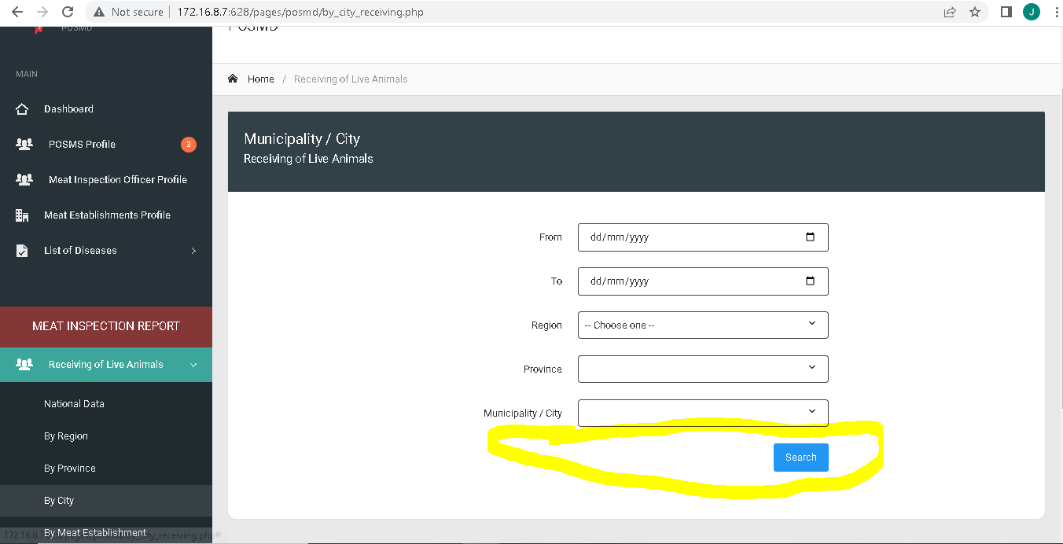

Resolved with the revise user interface

July 23, 2022

Sidebar :

Remove By: Regional Data, Provincial Data, City / Municipality Data, Meat Establishment Data : resolved with user interface July 23, 2022

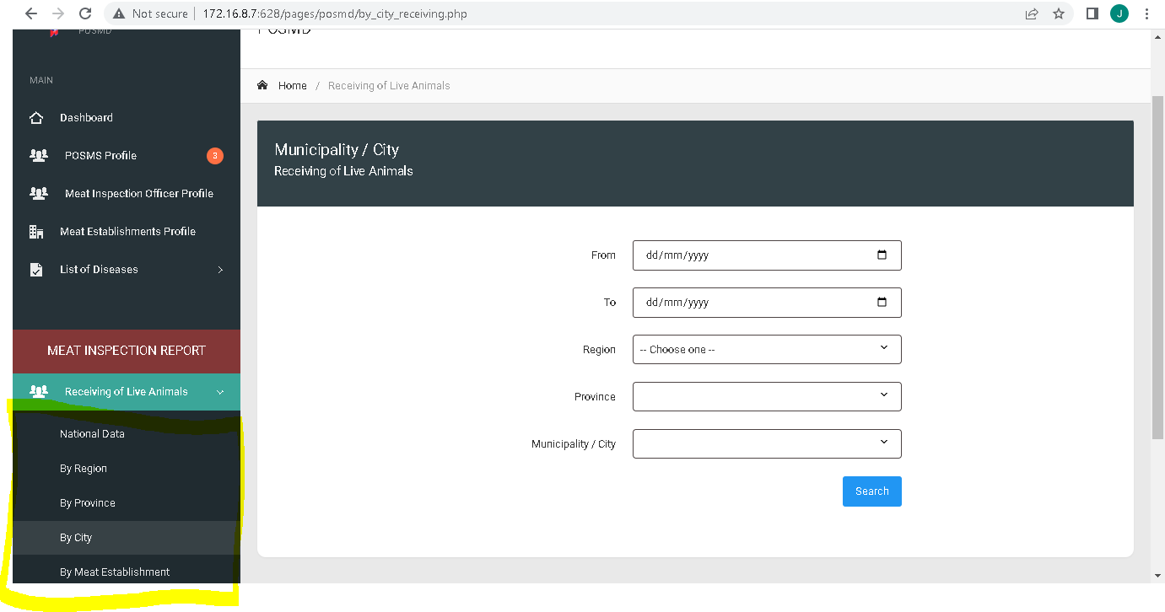

Resolved with the revise user interface

July 23, 2022

When filtering date start and end present date must be selected

Not ahead on the present date: Pending

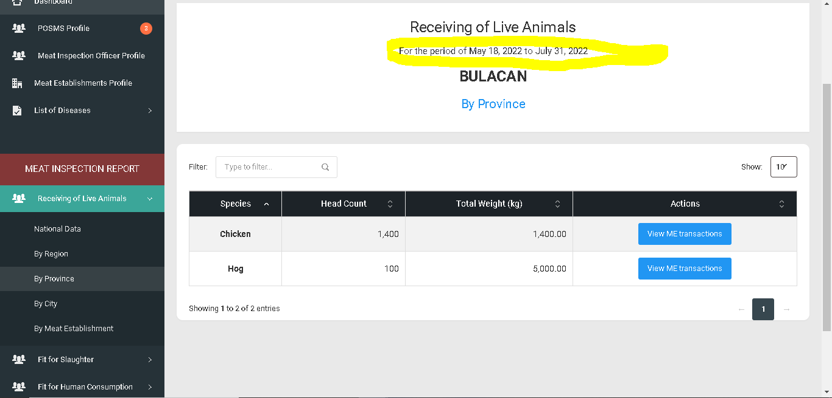

Consolidated Slaughter data

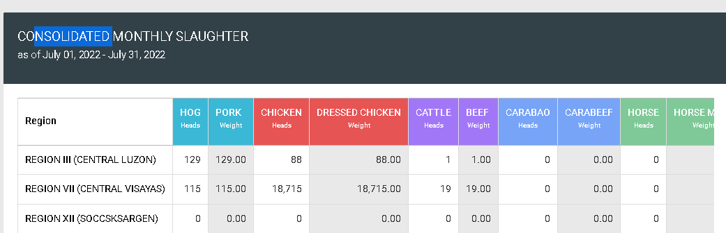

Resolved with the revise user interface

July 23, 2022

By categorize (national,regional, provincial )

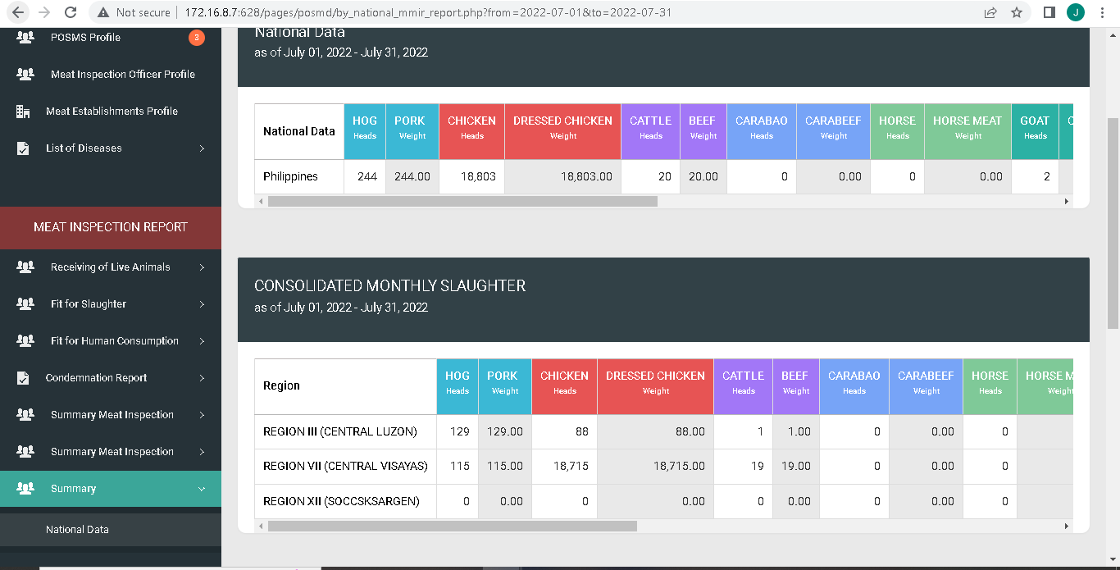

Resolved with the revise user interface

July 23, 2022

Move to Fit for human consumption and add additional card for the breakdown based on the category

Example: if region is selected on sidebar the other card will be the breakdown for province same in summary patch on july 20,2022

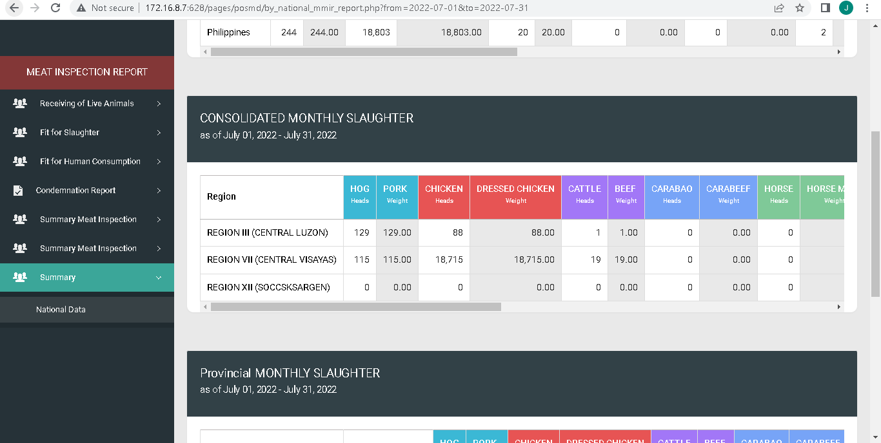

Resolved with the revise user interface

July 23, 2022

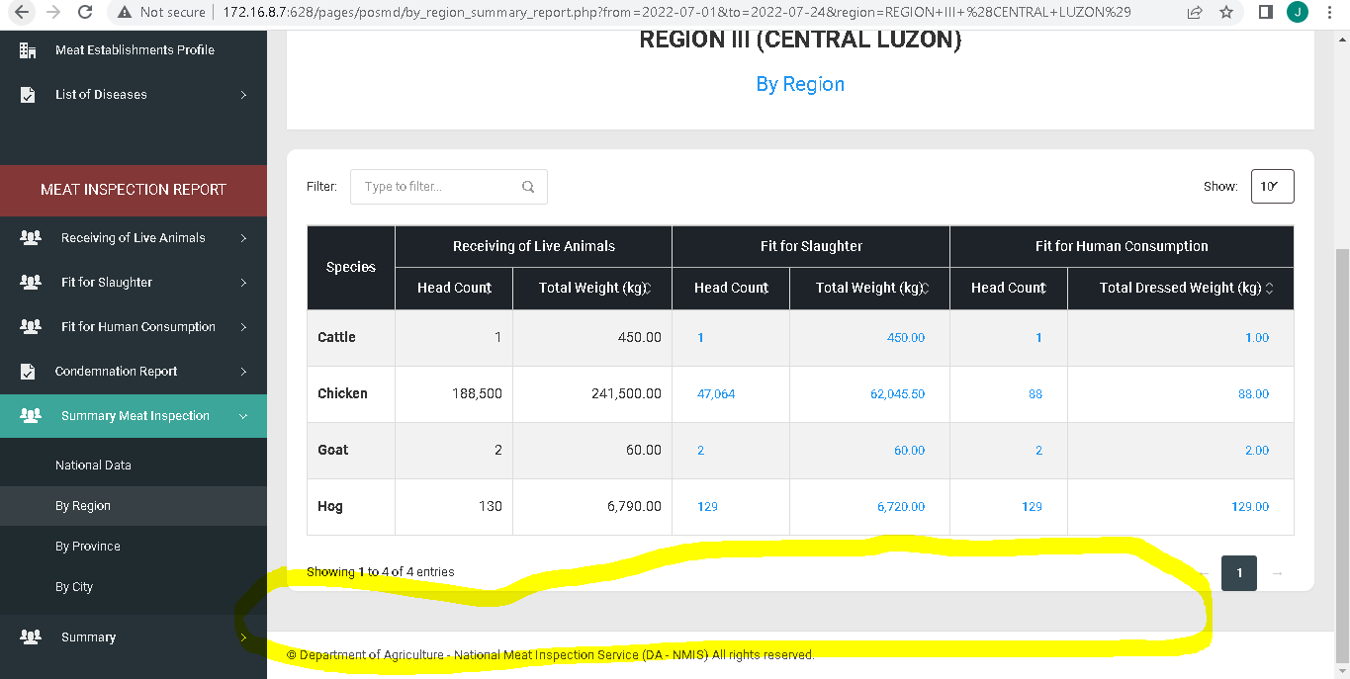

Spacing Sidebar

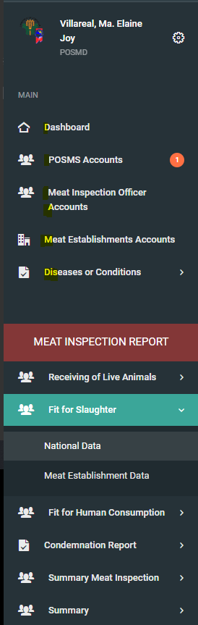

Resolved with the revise user interface

July 23, 2022

­

Add meat type in Fit for human consumption

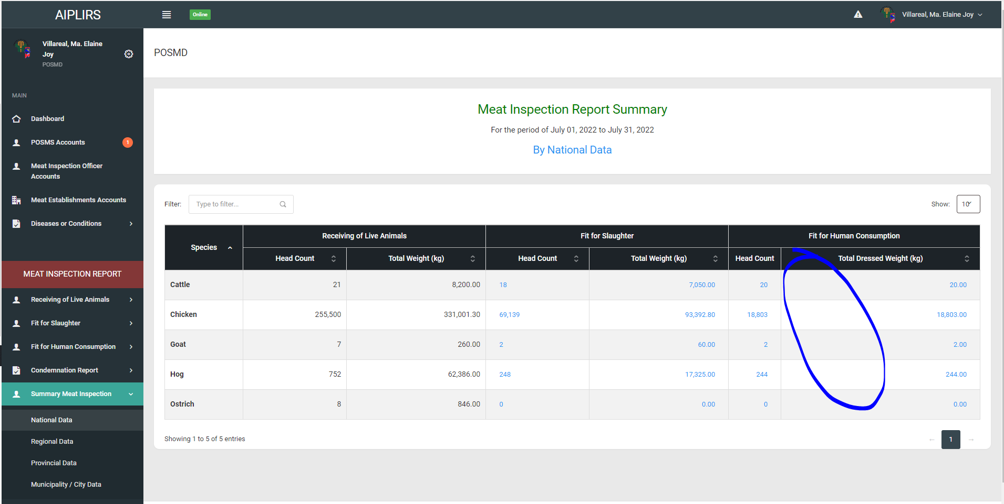

Resolved

August 11, 2022­­­